4.0 PROBLEM STATEMENT
Inconsistency in Data Entry
KADA's data management issues are a significant concern, primarily due to inconsistent data formats and reliance on manual data entry. These inconsistencies can cause significant errors, as data entered manually is prone to human error. It is also inefficient to always fill out repetitive information such as employees' names and ID numbers for applications.
Data Management Issues
KADA uses paperwork as the main medium for membership and loan applications. Large volumes of documents can be hard to handle as they can be misplaced or lost during transfer or storage. Storage for the application forms also raises a problem as physical storage of documents requires space and that can lead to organisational challenges. Documents are also hard to retrieve when they need to be reviewed. It also raises security and privacy issues as sensitive information is involved
Limitations in Data Collection and Analysis
The manual method of collecting data will cause the data not to be categorised and not organised well. KADA expresses their difficulty in generating monthly and yearly reports of profits and losses. The lack of data analysis due to insufficient data can affect the corporation’s decision-making process for prospects.
Reliance on Human Resources
The manual process heavily relies on large amounts of human resources as the whole membership and loan application process is extensive, making it labour-intensive and contributing to more costs. It also makes it more prone to human errors as various entities handle the entire process. There could be errors when reviewing applications to make sure the information provided is valid and failure to record payment details.

8.3 PERT DIAGRAM

Activity |  | Predecessor | Duration (Days)
A | Collecting information from interview | None | 3
B | Meeting with team member to plan and divide task | None | 1
C | Determine user requirement for the proposed system | A | 2
D | Extracting key information from the interview | A | 1
E | Determine scope of study | B | 1
F | Determine problem statement | D | 2
G | Determine objective of the study | E | 2
H | Determine scope of project | E | 1
I | Proposed solutions | F | 3
J | Describe the current business process | I | 2
K | Design a logical DFD of AS-IS system | D, I | 4
L | Determine functional and non-functional requirements | K | 2

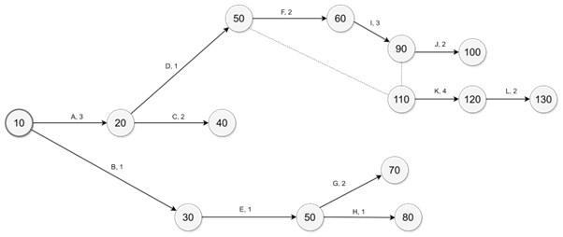

Figure 8.3.1 Pert Diagram

9.0 REQUIREMENT ANALYSIS

9.1 CURRENT BUSINESS PROCESS

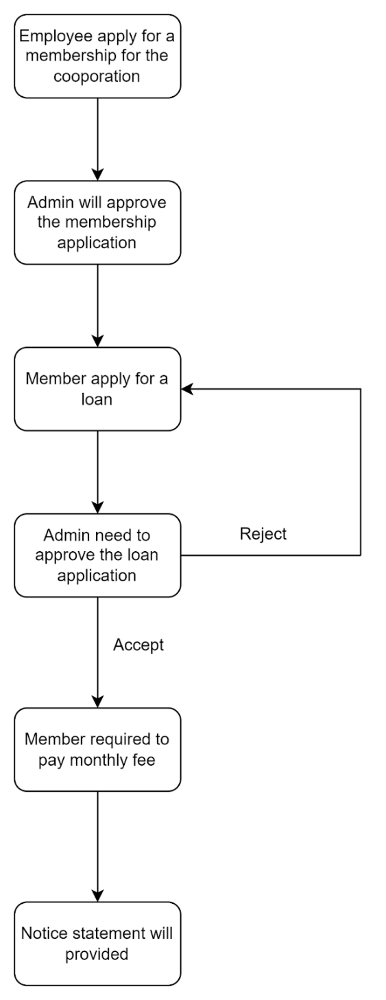
DFD (AS - IS)
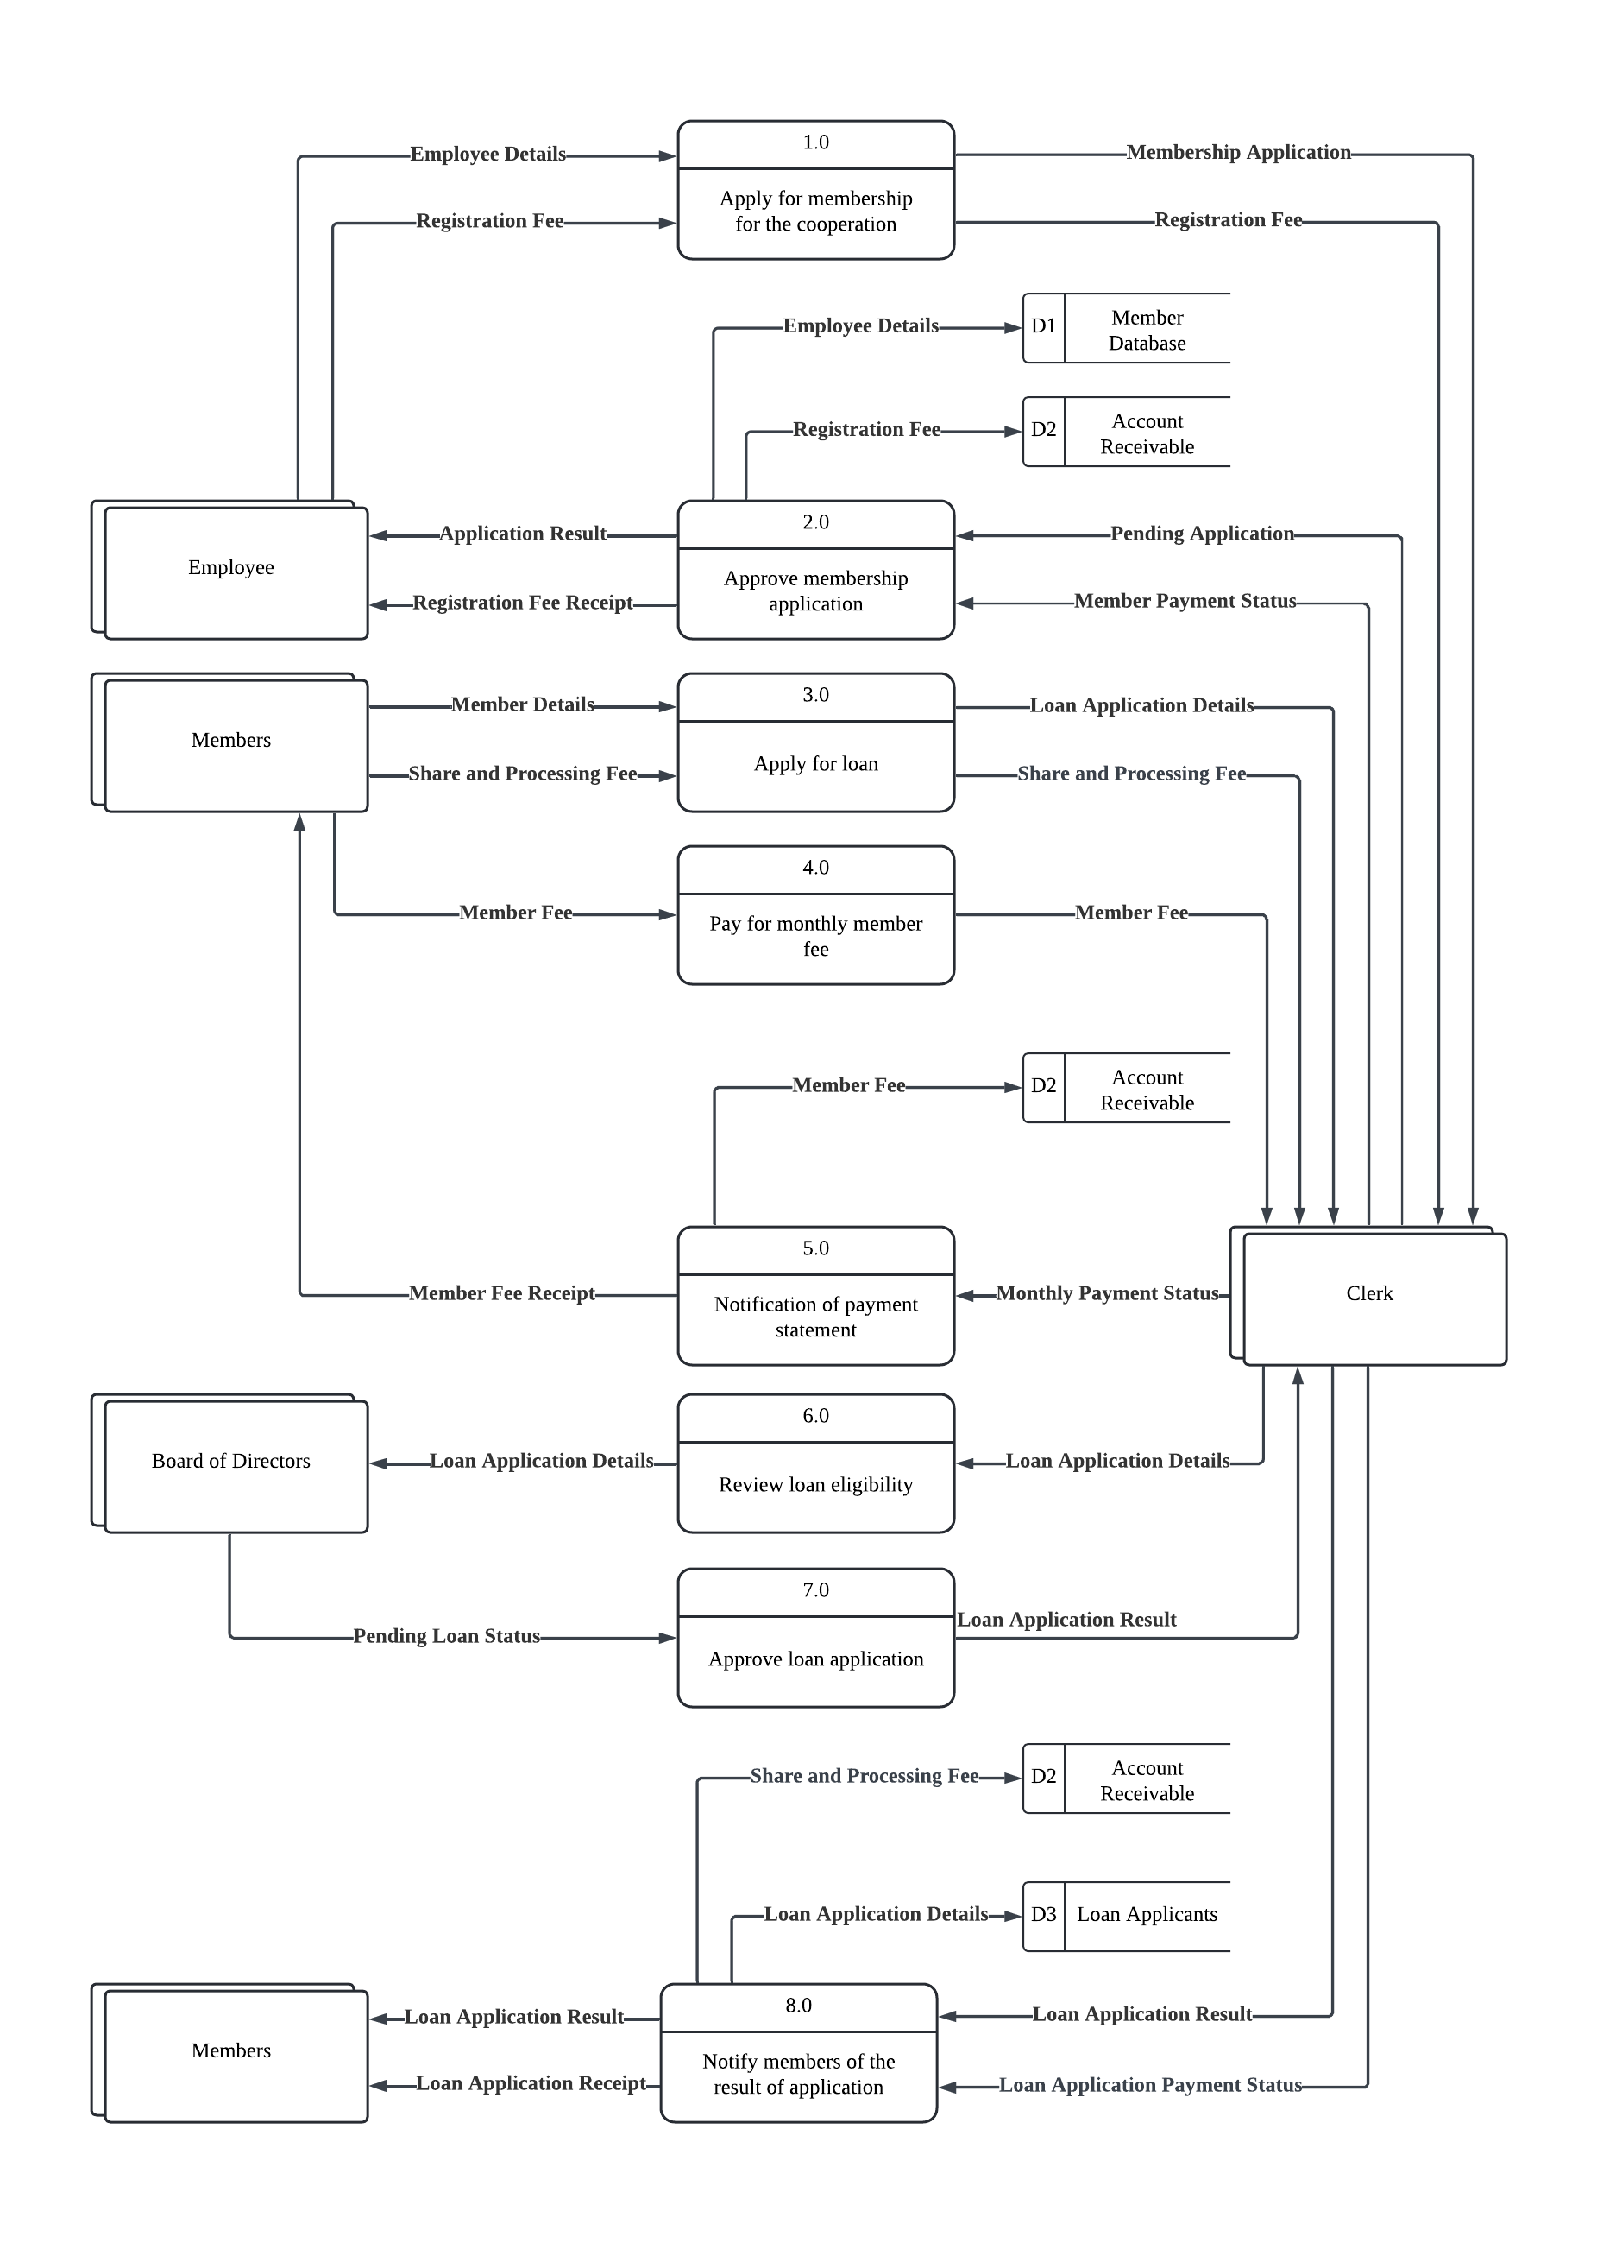

LOGICAL DFD (TO – BE)
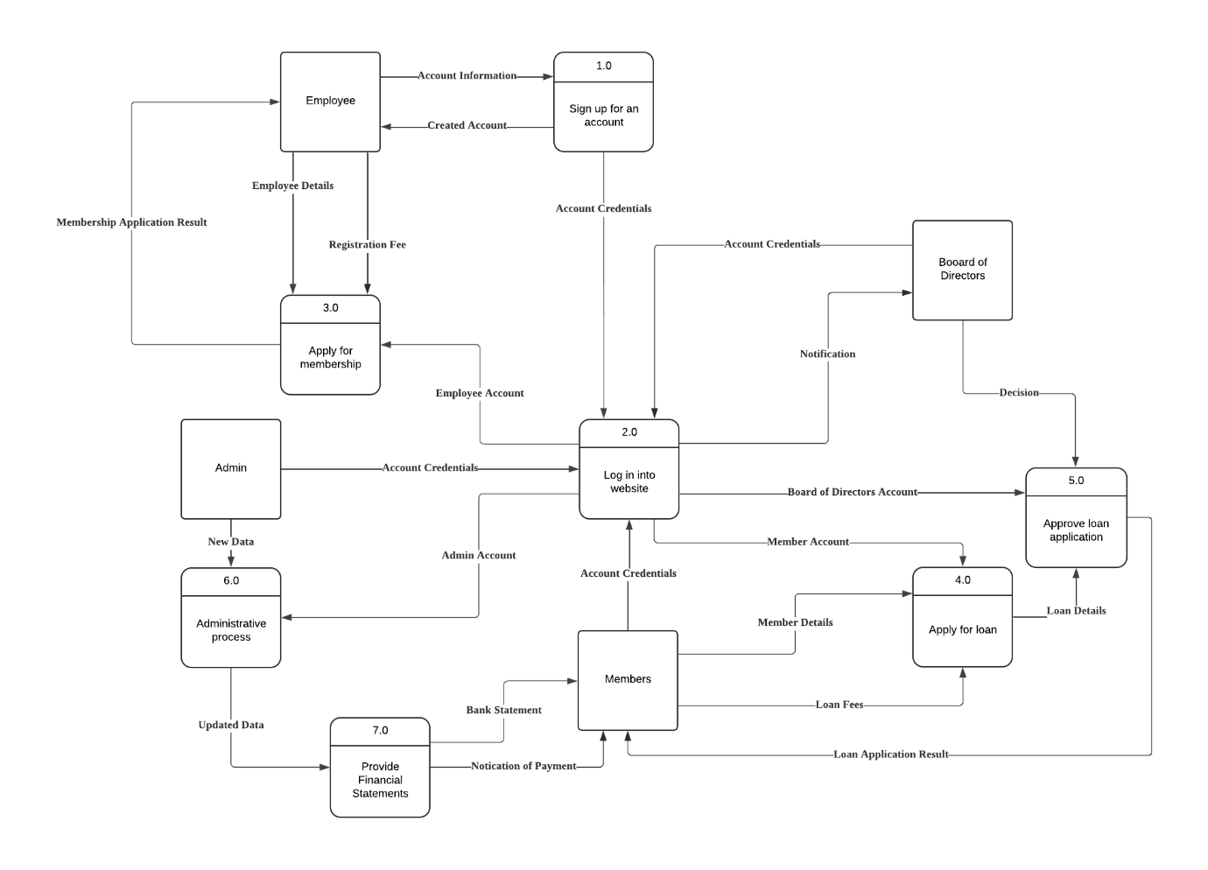

CHILD LOGICAL DFD (TO – BE)
